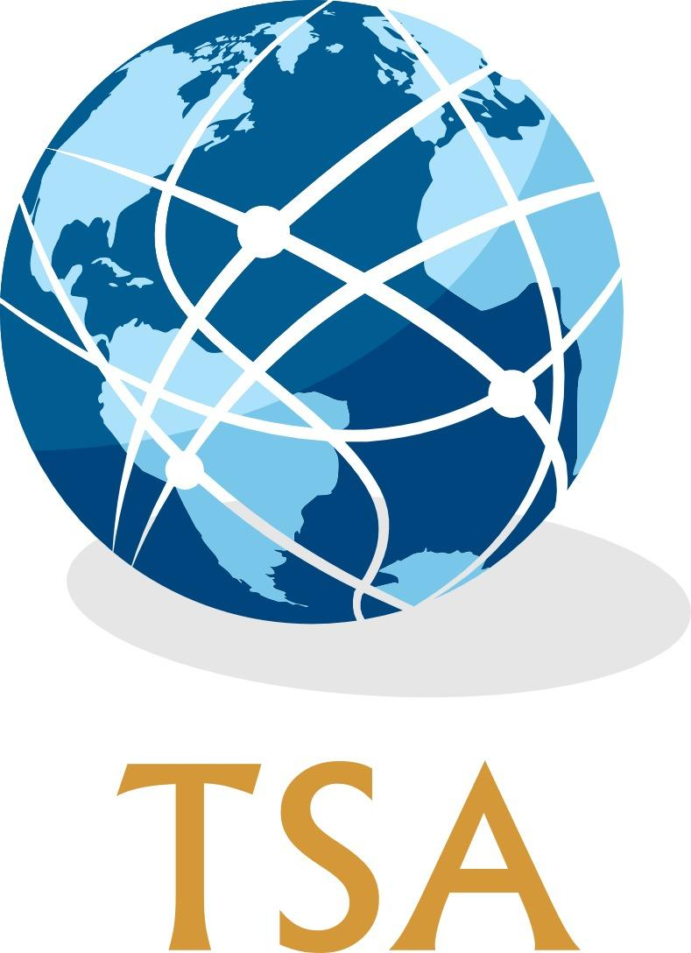

**Transatlantic Studies Association  
19th Annual Conference  
Centre for International Studies, ISCTE-IUL, Lisbon  
5-7 July 2021**

**_________**

**Call for Papers**

**Submissions are invited for the 2021 Annual Conference**  
  
**KEYNOTE LECTURES**

**Professor Andrew Moravcsik (Princeton University)**

*“Why meeting NATO’s 2% target would make Europe (and the West) less secure”*

AND

**Professor Anna Brickhouse (University of Virginia)  
Mayflower Lecture**

*“From Lima to Lisbon: Earthquake History in the Making”*

Co-sponsored by the University of Plymouth:

*‘Mayflower 400: Atlantic Crossings’*

AND

**Dr Dan Plesch (SOAS, University of London)**

*“Twilight or New Dawn in Transatlantic Relations?”*

PLUS

**A Roundtable discussion on***:*

**Southern Transatlantic Connections and the Cold War****_________**

The TSA is a broad network of scholars who use the ‘transatlantic’ as a frame of reference for their work in a variety of disciplines, including (but not limited to): history, politics and international relations, and literary studies. All transatlantic-themed paper and panel proposals from these and related disciplines are welcome.

The conference is organised around a number of subject themes, each of which is convened by members of the conference programme committee. If you would like to discuss your paper or panel proposal prior to submission, please contact the relevant programme committee members. This year’s subject themes are:

1. *Diplomatic and international history*David Ryan, [david.ryan@ucc.ie](mailto:david.ryan@ucc.ie), Chris Jespersen, [christopher.jespersen@ung.edu](mailto:christopher.jespersen@ung.edu)
2. *Political and intellectual history*   
   Joe Renouard, [jrenoua1@jhu.edu](mailto:jrenoua1@jhu.edu), Ana Monica Fonseca, [ana_monica_fonseca@iscte-iul.pt](mailto:ana_monica_fonseca@iscte-iul.pt)
3. *Social, cultural and religious history*

Kristin Cook, [kc31@soas.ac.uk](mailto:kc31@soas.ac.uk), Constance Post, [cjpost@iastate.edu](mailto:cjpost@iastate.edu)

1. *International Relations and Security Studies*

Luís Rodrigues, [luis.rodrigues@iscte-iul.pt](mailto:luis.rodrigues@iscte-iul.pt), Joe Renouard, [jrenoua1@jhu.edu](mailto:jrenoua1@jhu.edu)

1. *Literature, film, and theatre*   
   Donna Gessell, [donna.gessell@ung.edu](mailto:donna.gessell@ung.edu), Finn Pollard, [fpollard@lincoln.ac.uk](mailto:fpollard@lincoln.ac.uk)
2. *Business and finance*

Thomas Mills, [t.c.mills@lancaster.ac.uk](mailto:t.c.mills@lancaster.ac.uk), António Monteiro, [asousamonteiro@gmail.com](mailto:asousamonteiro@gmail.com)

1. *Latin America in a transatlantic context*

Robert Howes, [robert.howes@kcl.ac.uk](mailto:robert.howes@kcl.ac.uk), Pedro Seabra, [pedro.seabra@iscte-iul.pt](mailto:pedro.seabra@iscte-iul.pt)

1. *Ethnicity, race and migration*

Kristin Cook, [kc31@soas.ac.uk](mailto:kc31@soas.ac.uk), Ana Lúcia Sá, [ana.lucia.sa@iscte-iul.pt](mailto:ana.lucia.sa@iscte-iul.pt)

**Special subject theme:**

***‘Mayflower 400: Atlantic Crossings’***

**The TSA is pleased to join the University of Plymouth, England** in welcoming proposals that seek to place the Mayflower voyage within an Atlantic context, and that offer an opportunity to better understand, interrogate and develop the political, religious, scientific and economic forces which shaped the Atlantic world in this historical moment and beyond. In commemorating ‘Mayflower 400’, we seek to uncover and enable voices and identities which forged, or were forged by, Atlantic crossings of many kinds. The 2021 TSA conference thus welcomes scholars focusing on the Mayflower voyage and its legacies, or on early America from historical/cultural/literary perspectives. 

**Conference Format and COVID-19**

In light of impediments posed by the COVID-19 pandemic on mass gatherings, international travel and university finances, the current intention is for the TSA 2021 conference to take place in a blended format, with some aspects on site in Lisbon and others online. If the situation requires it, all aspects of the conference will take place online. The TSA Management Committee and 2021 conference organisers will continue carefully monitoring the COVID-19 situation and will follow guidance from relevant national health agencies. The precise format of the conference will be determined in the coming weeks and all participants will be informed. Our intention is to ensure, as far as possible, that restrictions caused by the pandemic do not act as an impediment to anyone wishing to participate in the conference.

**Submissions to the 2020 Call for Papers**

At its annual meeting in 2020, the TSA Management Committee agreed to honour acceptances of papers and panels submitted for the 2020 conference for the TSA conference in 2021, should those concerned wish to attend. We are now asking that all those wishing to present at the conference in 2021 submit papers and panels to the current conference email address (see below), whether your submission for 2020 was accepted or not. If you received an email accepting your previous submission, please make a note of this in the body of your email and your submission will be automatically accepted.

**Submission Instructions**

Panel proposals should constitute three or four presenters and a Chair (as well as a discussant if desired). Panel proposals should be sent by email as one document attachment to [tsalisbon2021@gmail.com](mailto:tsalisbon2021@gmail.com), and include:

* 300-word overview of the panel theme;
* 300-word abstracts for each of the papers;
* 100-word author biographies;
* 2-page CVs for all participants.

The subject line of the email for panel proposals should read: ‘TSA Proposal-[Last name of panel convenor]-[Subject theme]’ (state ‘Other’ if not falling under listed themes) (E.g. ‘TSA Proposal-Smith-Diplomacy and International History’).

Individual paper proposals should be sent by email as one document attachment, and include:

* 300-word abstract for the paper
* 100-word author biography;
* 2-page CV.

The subject line of the email for paper proposals should read: ‘TSA Proposal-[Last name of presenter]-[Subject theme]’ (state ‘Other’ if not falling under listed themes) (E.g. ‘TSA Proposal-Smith-Other).

**Travel Grants**

The TSA particularly welcomes proposals from new members and junior scholars. Travel grants of £150 each are available to support early career scholars presenting a paper at the conference. As a result of funding from the Halle Foundation, the TSA is able this year to offer a number of additional travel grants to support early career scholars presenting a paper on any aspect of relations between the United States and Germany.

If wishing to apply for a travel grant, applicants should indicate this in the body of the email when submitting their paper or panel. If papers are believed to qualify for Halle Foundation funding, this should be indicated. In addition to the materials requested above, travel grant applicants should include a brief statement explaining why it is important for them to attend the TSA conference. For further details about TSA travel grants, see the TSA website: [www.transatlanticstudies.com](http://www.transatlanticstudies.com).

**Extended deadline for panel and paper proposals: 20 March 2021**All paper and panel proposals, and travel grant applications, should be sent to the conference email: [tsalisbon2021@gmail.com](mailto:tsalisbon2021@gmail.com).

**NB: The working language of the conference will be English.**

**Contact details**

Chair of TSA: Christopher Jespersen: [christopher.jespersen@ung.edu](mailto:christopher.jespersen@ung.edu)

Vice-Chair of TSA: Thomas Mills: [t.c.mills@lancaster.ac.uk](mailto:t.c.mills@lancaster.ac.uk)

Secretary of TSA: Kristin Cook: [kc31@soas.ac.uk](mailto:kc31@soas.ac.uk)

Local Organiser: Luís Rodrigues, [luis.rodrigues@iscte-iul.pt](mailto:luis.rodrigues@iscte-iul.pt)

TSA Charity Number: SC039378

[www.transatlanticstudies.com](http://www.transatlanticstudies.com)