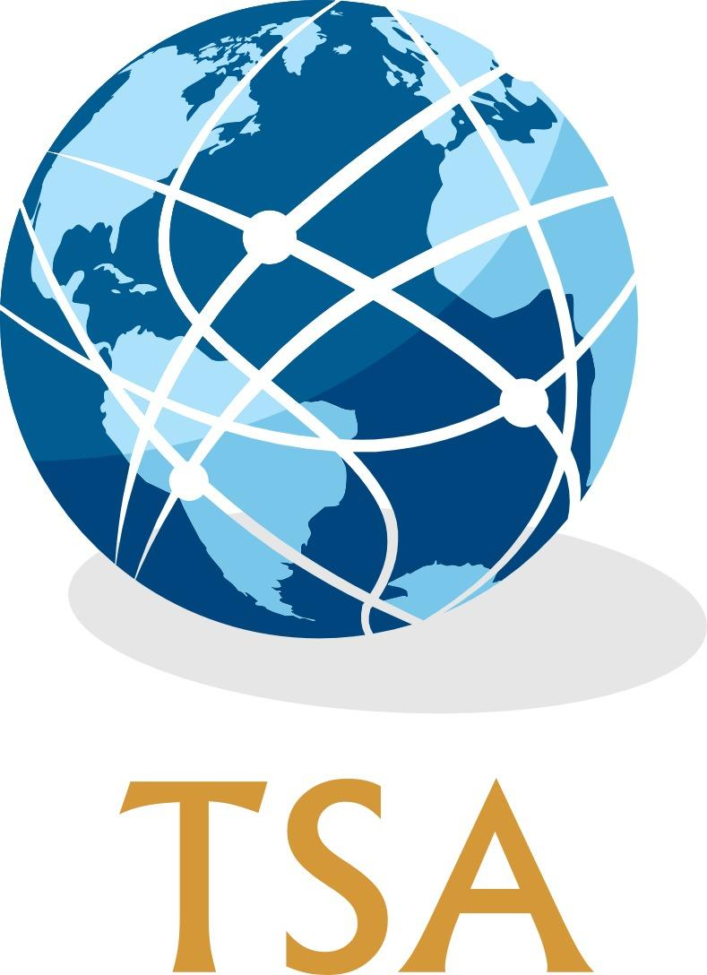

**Transatlantic Studies Association  
20th Annual Conference  
University of Kent, Canterbury  
4-6 July 2022**

**_________**

**Call for Papers**

**Submissions are invited for the 2022 Annual Conference**

**KEYNOTE LECTURES**

**Professor Jussi Hanhimäki (Graduate Institute of International and Development Studies)**

*“Pax Transatlantica: America and Europe in the Post-Cold War Era”*

AND

**Dr Sarah Meer (University of Cambridge)**

*“American Claimants: Transatlantic Tales of Humility and Grandeur”*

AND

**Professor Mark Webber (University of Birmingham)**

*“NATO in a Tripolar World: Does the New Strategic Concept Deliver?”*

PLUS

**A Roundtable discussion on***:*

**The End of an Era? The Transatlantic Alliance in International Politics from 9/11 to Covid-19****_________**

The TSA is a broad network of scholars who use the ‘transatlantic’ as a frame of reference for their work in a variety of disciplines, including (but not limited to): history, politics and international relations, and literary studies. All transatlantic-themed paper and panel proposals from these and related disciplines are welcome.

The conference is organised around a number of subject themes, each of which is convened by members of the conference programme committee. If you would like to discuss your paper or panel proposal prior to submission, please contact the relevant programme committee members. This year’s subject themes are:

1. *Diplomatic and international history*David Ryan, [david.ryan@ucc.ie](mailto:david.ryan@ucc.ie), Chris Jespersen, [christopher.jespersen@ung.edu](mailto:christopher.jespersen@ung.edu)
2. *Political and intellectual history*   
   Joe Renouard, [jrenoua1@jhu.edu](mailto:jrenoua1@jhu.edu), Gaynor Johnson, [G.L.Johnson@kent.ac.uk](mailto:G.L.Johnson@kent.ac.uk)
3. *Social, cultural and religious history*

Finn Pollard, [fpollard@lincoln.ac.uk](mailto:fpollard@lincoln.ac.uk), Kathryn Gray, [kathryn.gray@plymouth.ac.uk](mailto:kathryn.gray@plymouth.ac.uk)

1. *International Relations and Security Studies*

Michele Testoni, [mtestoni@faculty.ie.edu](mailto:mtestoni@faculty.ie.edu), Joe Renouard, [jrenoua1@jhu.edu](mailto:jrenoua1@jhu.edu)

1. *Literature, film, and theatre*   
   Donna Gessell, [donna.gessell@ung.edu](mailto:donna.gessell@ung.edu), Finn Pollard, [fpollard@lincoln.ac.uk](mailto:fpollard@lincoln.ac.uk)
2. *Transatlantic memory and heritage*

Kristin Cook, [kc31@soas.ac.uk](mailto:kc31@soas.ac.uk), Kathryn Gray, [kathryn.gray@plymouth.ac.uk](mailto:kathryn.gray@plymouth.ac.uk)

1. *Latin America in a transatlantic context*

Robert Howes, [robert.howes@kcl.ac.uk](mailto:robert.howes@kcl.ac.uk), Thomas Mills, [t.c.mills@lancaster.ac.uk](mailto:t.c.mills@lancaster.ac.uk)

1. *Ethnicity, race and migration*

Thomas Mills, [t.c.mills@lancaster.ac.uk](mailto:t.c.mills@lancaster.ac.uk), Tony McCulloch, [tony.mcculloch@ucl.ac.uk](mailto:tony.mcculloch@ucl.ac.uk)

**Special subject theme:**

The TSA is pleased to join SOAS and the University of York in welcoming proposals that seek to better understand the UK-US nuclear relationship as enshrined in the 1958 Mutual Defence Agreement (MDA). This arrangement formalizes the US support for the UK’s nuclear weapons system, and regulates exchanges of sensitive nuclear materials and know-how between the two countries. The Mutual Defence Agreement has been regularly renewed since its inception, with the next renewal due in 2024.

While the nuclear relationship is commonly thought of as being at the heart of what is referred to as the “special relationship”, there is no academic centre in either the US and UK that has a sustained focus on this topic, and scholarly literature about it is sparse. The TSA thus encourages proposals for papers that elucidate and interrogate the Mutual Defence Agreement and UK-US nuclear relationship, drawing on traditional strategic studies, peace studies and critical perspectives.

For queries, please contact Professor Dan Plesch: [dp27@soas.ac.uk](mailto:dp27@soas.ac.uk)

**Conference Format**

The TSA fully intends to hold its 2022 annual conference as a full in-person meeting. If there are unexpected and significant limitations on gatherings and international travel, the TSA Management Committee will reconsider the format accordingly. While primarily an in-person meeting, we will reserve a limited number of slots for online panels. These panels must be wholly online (i.e. all presenters and the chair will participate online); individual paper submissions will not be considered for online delivery. If you wish your panel to be delivered wholly online, please explain briefly when making your submission why this needs to be the case and/or why the panel would benefit from this format of delivery. Please note that panels and papers accepted for in-person delivery will not subsequently be considered for online delivery.

**Other formats**

In addition to the subject themes above, we welcome papers and panels on any aspect of transatlantic studies. Interdisciplinary papers and panels are particularly welcome, as are innovative formats, such as roundtables, workshops or multimedia presentations.

**Submission Instructions**

Panel proposals should constitute three or four presenters and a Chair (as well as a discussant if desired). Panel proposals should be sent by email as one document attachment to [tsakent2022@gmail.com](mailto:tsakent2022@gmail.com), and include:

* 300-word overview of the panel theme;
* 300-word abstracts for each of the papers;
* 100-word author biographies;
* 2-page CVs for all participants.

The subject line of the email for panel proposals should read: ‘TSA Proposal-[Last name of panel convenor]-[Subject theme]’ (state ‘Other’ if not falling under listed themes) (E.g. ‘TSA Proposal-Smith-Diplomacy and International History’).

Individual paper proposals should be sent by email as one document attachment, and include:

* 300-word abstract for the paper
* 100-word author biography;
* 2-page CV.

The subject line of the email for paper proposals should read: ‘TSA Proposal-[Last name of presenter]-[Subject theme]’ (state ‘Other’ if not falling under listed themes) (E.g. ‘TSA Proposal-Smith-Other).

**Please note: all submissions must come to the conference email address to be considered by the programme committee.**

**Travel Grants**

The TSA particularly welcomes proposals from new members and junior scholars. Travel grants of £150 each are available to support early career scholars presenting a paper at the conference. As a result of funding from the Halle Foundation, the TSA is able this year to offer a number of additional travel grants to support early career scholars presenting a paper on any aspect of relations between the United States and Germany.

If wishing to apply for a travel grant, applicants should indicate this in the body of the email when submitting their paper or panel. If papers are believed to qualify for Halle Foundation funding, this should be indicated. In addition to the materials requested above, travel grant applicants should include a brief statement explaining why it is important for them to attend the TSA conference. For further details about TSA travel grants, see the TSA website: [www.transatlanticstudies.com](http://www.transatlanticstudies.com).

**Extended deadline for panel and paper proposals: 20 March 2022**All paper and panel proposals, and travel grant applications, should be sent to the conference email:

[tsakent2022@gmail.com](mailto:tsakent2022@gmail.com).

**Contact details**

Chair of TSA: Thomas Mills: [t.c.mills@lancaster.ac.uk](mailto:t.c.mills@lancaster.ac.uk)

Vice-Chair of TSA: Kristin Cook: [kc31@soas.ac.uk](mailto:kc31@soas.ac.uk)

Local Organiser: Gaynor Johnson, [G.L.Johnson@kent.ac.uk](mailto:G.L.Johnson@kent.ac.uk)

TSA Charity Number: SC039378

[www.transatlanticstudies.com](http://www.transatlanticstudies.com)